**Workflow Outline: HECAP Objective #4 (Community-Based SDOH Screening)**

**Document Objective:** To outline and communicate feedback regarding the proposed workflow and the language used in the screening workflow between HECAP and clinical teams.

**Study Objective:** The goal of this program is to conduct a pilot testing to determine whether individuals in the community will complete an online social determinants of health (SDOH) screening survey and if they would be willing to share their information to potentially be connected to clinical and SDOH resources.

**Study Evaluation:**

* Number of times the QR code/survey link was opened
* Number and demographics of participants who completed the survey
* Number and demographics of participants who screened negative
* Number and demographics of participants who screened positive
* Number and demographics of participants who screened positive and consent to social work referral
* Number and demographics of participants who screened positive and did not consent to social work referral

**Study Workflow:**

1. **Recruitment:** 
   * QR code or web link (in flyer/email) to access the survey
2. **Survey and Demographic Information Form (Deidentified and includes “Refuse” option for all questions):** 
   * Rush Social Determinant of Health Survey questions
   * Demographic Form: age, race, ethnicity, gender, zip code
   * Open Ended Question (optional): Are there any factors that influenced your decision to share or not share your information?
3. **Survey Result and Invitation Page:**
   * If Screened Negative
     + Thank you message (with resource list)
   * If Screened Positive for SDOH (if answered “Yes” > 2 of the questions)
     + Thank you message (with resource list)
     + Invitation to share information with the social workers team for additional support
       - Yes or No
       - If “Yes "for consent:
         * Sign (type name)
         * Name, email and phone
       - If “No" for consent:
     + Open Ended Question (optional): Are there any factors that influenced your decision to share or not share your information?
   * Invitation for Contact of Future Research
     + Yes or No
       - If yes and screened negative/screened positive and refuse to consent, then:
         * Name, email and phone

**Detailed SDOH Screening Workflow**

**1. Recruitment**

* Recruitment Methods:
  + Flyers will be posted at community partner sites with a QR code/link to access the SDOH screening survey (see next page, [Link](https://rush.sharepoint.com/:w:/r/teams/HealthEquityCareAnalyticsPlatformProject/Shared%20Documents/Analytics/Primary%20Research/6.%20SDoH-%20Community-based%20health%20interventions%20Project/Amendment%20%235/Objective%20%234_%20Flyer_Community%20SDOH%20Screening%20Draft_02.01.24.docx?d=w1633b833fe0d4fa299712f3bf76a6e59&csf=1&web=1&e=Xnw9hU) in Teams)
  + Community-based organizations may also email the QR code/link to community members using the email script below.

|  |  |
| --- | --- |
| **Invitation Email** | |
| Finalized Text | Email Subject: Rush survey to connect you with social resources    Email Content:    Dear West Side Community Members,  Partners at Rush are testing a survey platform to help connect people to social resources in the community. This survey will ask you some quick questions about your health and wellbeing. You may be eligible for support from social workers at Rush.   * Connection to social work * June/July timeframe * Research objectives     This survey is confidential. Your information will only be saved if you agree to participate. If you are eligible, we are partnering with Rush to help connect community members to resources. If you are eligible for resources, a member of our team will contact you. A Rush Community Health Team member may refer you to services.    "Click here" to complete the survey.    Thank you for considering participating in this program. Together, we can make a meaningful impact on the wellbeing of our community. |

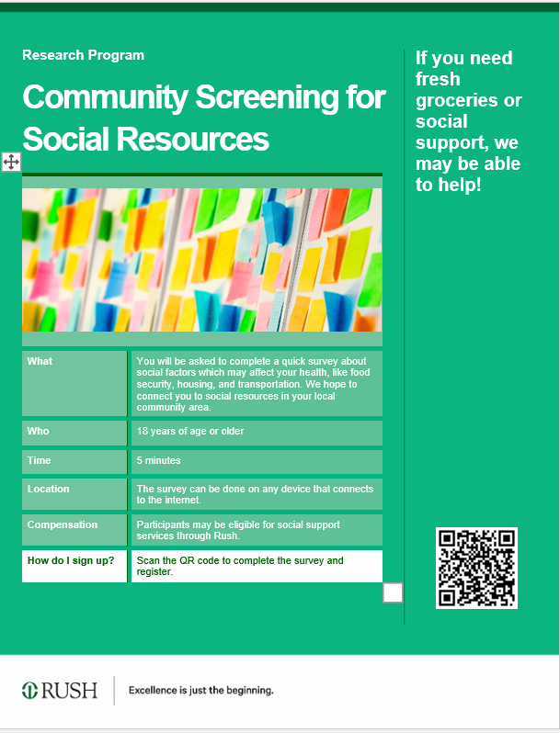

|  |  |
| --- | --- |
| **Title and Header Text** | |
| Finalized Text | Community Screening for Social Resources  If you need fresh groceries or social support, we may be able to help! |

|  |  |
| --- | --- |
| **Supporting Text** | |
| Finalized Text | |  |  |  | | --- | --- | --- | | **What** |  | You will be asked to complete a quick and confidential survey about social factors which may affect your health, like food, housing, and transportation. This program's goal is to pilot testing the effectiveness of using electronic devices to administer social resources survey. | | **Why** |  | These social factors are important to your health, and we can help connect you to resources if needed. | | **Who** |  | 18 years of age or older. | | **Time** |  | 5 minutes. | | **Location** |  | The survey can be done on any device that connects to the internet. | | **Benefits** |  | Participants may be eligible for social support services through Rush. | | **How do I sign up?** |  | Scan the QR code or go to [**https://hecap.rush.edu/**](https://hecap.rush.edu/) to complete the survey and register. | |

## 2. Survey and demographic information form:

* Patients will be directed to the survey page from the QR code/link:

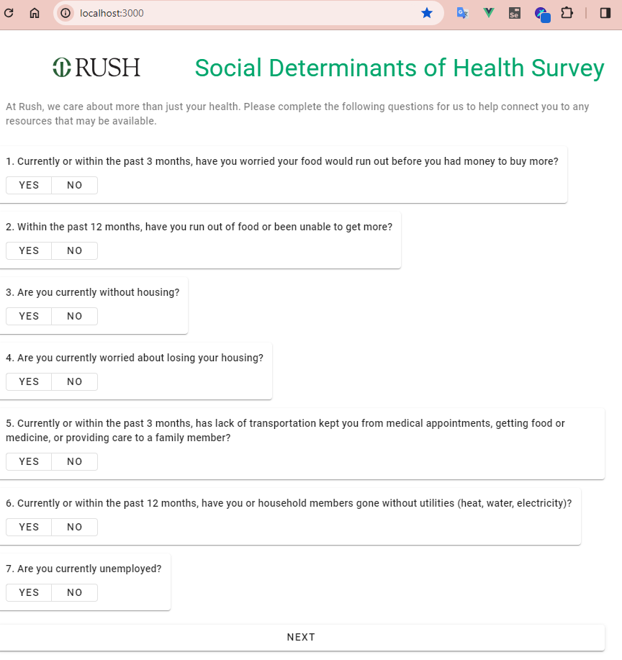

Survey Title and Introduction

|  |  |
| --- | --- |
| **Finalized Text** | Survey Title: Community Screening for Social Resources  Body: At Rush, we care about more than just your health. We invite you to take part in a quick survey to see if you may be eligible for resources, like food and utilities support, in your community.  Our objective is to pilot a screening program aimed at gauging community interest in accessing social resources online and willingness to share information, potentially facilitating connections to both clinical and social support services that are available. |

## 3. Study Result and Invitation Page:

* After completing the survey, a brief survey result will be provided. A general Rush resources page for SDOH needs will also be available for patients to view.

**Screened Negative:**

|  |  |
| --- | --- |
|  | **Negative Screen** |
|  | If screened Negative: (If answered “No” to all questions)  **Thank you for Completing the Survey!**  Your participation is invaluable and greatly appreciated. You screened NEGATIVE but may have needs or know others with needs.  “[Click here](https://www.rush.edu/services/social-work-and-community-health-services)” to see additional resources for any immediate needs. |
|  | **Would you be interested in staying connected and receiving updates about our upcoming programs?**  Yes = Demographic From  No = Thank you Messages  Yes = Demographic From  Thank you for your interest. Please fill out the demographic to stay in touch and contact for future programs. Your information will be kept confidential and will not be shared with any third parties.  **Demographic Form**: Name, Email, Phone  No = End Page  Thank you for your consideration. We understand and respect your decision. Your participation is crucial in advancing our understanding of social determinants of health and shaping future research initiatives.  If you have any questions or concerns about the study, please feel free to reach out to us at hecap@rush.edu.  [Add ‘Go back to Home’ button] |

|  |  |
| --- | --- |
| POSITIVE SCREEN | |
|  | If Screened Positive for SDOH (if answered “Yes” > 2 of the questions)  **Thank you for Completing the Survey!**  Your participation is invaluable and greatly appreciated. You screened POSITIVE and may have needs.  “Click here” to see additional resources for any immediate needs.  **Would you like Rush to connect you with a social worker or community health worker for available support?**  Rush may connect you with a social worker or community health worker for the support available. If you would like to be connected, or included in future research, please click “**Yes**” to complete demographic and consent form. Click “**No**” to be exited.  If NO = = Why refuse?  If Yes = Consent Form/Demographic form |
|  | **If NO = Why refuse?** |
|  | If **NO** = Thank you message for your consideration. We understand and respect your decision.  If applicable, please explain why you prefer not to be contacted by a social worker or community health worker for available support. Your response will help us enhance future experiences.  **Would you be interested in staying connected and receiving updates about our upcoming programs?**  No = Go to END Page  Yes = Go to Demographic form  Yes = Demographic From  Thank you for your interest. Please fill out the demographic to stay in touch and contact for future programs. Your information will be kept confidential and will not be shared with any third parties.  **Demographic Form**: Name, Email, Phone  **Direct to end page after done.** |
|  | **Yes = Consent Form/Information form** |
|  | Thank you for your interest. Please fill out the consent and demographic form to enroll in the program. Your information will be kept confidential and will not be shared with any third parties.  Summary Consent:  The purpose of this program to pilot a screening program aimed at gauging community interest in accessing social resources online and willingness to share information, potentially facilitating connections to both clinical and social support services that are available.  You have completed a standard survey about your health. Responses will be viewed by researchers and clinical providers at Rush. If you screen positive for any SDOH needs and would like to talk to a community health worker, a Rush team member will reach out to help connect you with resources.  By providing your demographic information and consent, you agree to be contacted by the Rush team. Your information will be securely stored and will not be shared with any third parties. A copy of the full consent is available to view here: [link](https://rush.sharepoint.com/:w:/r/teams/HealthEquityCareAnalyticsPlatformProject/Shared%20Documents/Analytics/Primary%20Research/6.%20SDoH-%20Community-based%20health%20interventions%20Project/Amendment%20%235/Objective%20%234_Draft_IRB%20Consent.docx?d=w1aa5ab73856a4192aec679458f6e6d97&csf=1&web=1&e=Xp9gib).  Consent Information: (*required fields)   * First and last name* * Phone or email address * Is it okay for a Social Worker/Community Health Worker to reach out to you?   **Would you be interested in staying connected and receiving updates about our upcoming programs?**   * *Check box: Yes or NO (optional)*   *Direct to end page after done.* |

|  |  |
| --- | --- |
| **END Page** | |
|  | Thank you for your responses.  Your participation is crucial in advancing our understanding of social determinants of health and shaping future research initiatives. If you have any questions about the study, please feel free to reach out to us at [hecap@rush.edu](mailto:hecap@rush.edu).  [Add ‘Go back to Home’ button] |